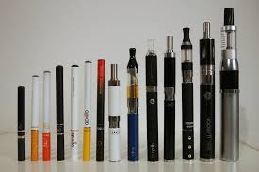

• E-cigarettes were produced to help existing smokers quit nicotine by reducing the level of nicotine. Health Canada has not approved them as a recognized nicotine cessation strategy.

• E-cigarettes now have the same legal restrictions as tobacco products in B.C. and fall under the “Tobacco and Vapor Products Control Act” (<http://www.bclaws.ca/civix/document/id/complete/statreg/96451_01>)

• The Food & Drugs Act requires that all products that contain nicotine receive approval by Health Canada. At this time, no product or company has received approval for e-cigarettes.

• All vapor products are prohibited on schools grounds in B.C., the same as cigarettes or other tobacco products. This applies even if the vape does not contain nicotine.

• A 2017 Canadian study of over 44,000 youth found that rates of e-cigarette use had increased, and 10% reported using at least once in the last 30 days (up from 3% in 2003). In the same study, youth who reported using in the last 30 days were more likely to report starting to smoke cigarettes at the 1-year follow-up.

• The impact of regularly inhaling the vapor products on long-term health are unknown. There are currently very few regulations for what chemicals e-juice can contain.

• In a Canadian study, 18% of high school non-smokers reported using an e-cigarette, and 31% expressed interest in trying them (Health Canada, 2015)

• E-juice is available without nicotine or in 3, 6, 12, 18mg of nicotine per ml of juice (sometimes more although it is not legal in Canada). A tobacco cigarette can have 8-20 mg of nicotine.

• A person using an e-cigarette is more likely to inhale more frequently, and hold the vapor in their lungs longer than someone smoking a cigarette.

• Marketing approaches for e-cigarettes mirror the advertising strategies that were used for cigarettes, which promoted them as cool, healthy and “everyone does it”.

**E-cigarettes & Youth  
Facts & Talking Points for Addressing E-Cigarette Use with Youth**

**FACTS**

• E-cigarettes are battery-operated devices that produce a vapor that can contain various levels of nicotine (propylene) or vegetable glycerin. They can mimic a cigarette or come with “mods” that increase the delivery of nicotine and vapor.

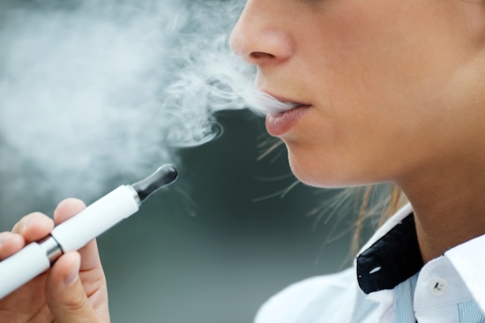

**TALKING POINTS FOR ADDRESSING E-CIGARETTE USE WITH YOUTH:**

• Remain calm and curious when talking with the student. Try to use open-ended questions (who, what, when, where, how) to help expand on their answers.

• Stay curious about what they get out of their e-cigarette use, what benefit they get from vaping or the reason for their use. This can help you understand how to provide options for other ways to meet these needs or provide education.

• Reiterate the school expectations, rules and consequences for vaping on school property. Educate the student about the legal status of vaping under the Tobacco and Vapor Products Control Act (see facts above).

• Many youth perceive vaping as harmless. Provide education about the limited long-term research on the impact of vaping, especially for youth who were not previously smokers.

• Build discrepancy between the youths goals and their vaping, such as athletics, musician or not perceiving themselves as a smoker.

**Example:** “Were you a smoker before starting vaping”, “no, vaping isn’t smoking”, “do you see yourself as a smoker when you’re older?” “no, smoking is gross” – build discrepancy between seeing smoking as “gross” but vaping being “harmless” through education and staying curious.

**Example:** if the student is an athlete, build discrepancy between the impact of vaping on their lungs, brain and physical health and their need for endurance, cardio or strength for their sport.

• Avoid black/white thinking or generalizations such as vaping is “bad” or “if you vape you will become a smoker”. It is far more beneficial to educate the youth on what we do know and potential effects their vaping could have on their body and brain. Try to connect the impact to something that they care about such as athleticism, family, money or school.

• Emphasize that we do not know the long-term health impacts of vaping because it is fairly new and there have been very few long-term studies. Offer them the choice of being in the group that future researchers are going to study to assess the impact of vaping (the guinea pigs) or the control group who have not vaped.

• Vaping manufacturers are using the same marketing strategies that big tobacco companies originally used for cigarettes to emphasize that they are healthy, safe, have no long-term health consequences, they’re “cool” and “everyone is using them”. Encourage them to critically think about what we know about cigarettes now and what we might find out about vapes once we have time to study them.

• Use resources (list provided below) when appropriate. If you feel that the student could benefit from support, refer them to Ginger or Kristi for further drug and alcohol support. You do not need to be an expert; it is good role modeling to acknowledge that you do not know everything about this topic.

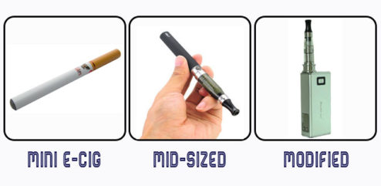

**RESOURCES:**

• E-cigarettes in Canada (Heart & Stroke Foundation)   
<https://www.apha.ab.ca/resources/Pictures/Ecigarettes%20in%20Canada%20Factsheet.pdf>

• E-Cigarette Fact Sheet   
<https://files.cdha.ca/DHcanada/e-cig-fact-sheet.pdf>

• E-Cigarettes on School Property (Interior Health)   
<https://healthyschoolsbc.ca/program/resources/138/en/92886/HP-TE-9010-Vapour-Products-in-and-On-School-Property-Final.pdf>

• Are E-Cigs Safer (Video)   
<https://www.youtube.com/watch?v=XvBVevkb5PU>